5.2.1 Line Integrals Worksheet

- Let C be the curve in parameterized by for .
- Evaluate the integral .
- Evaluate the integral .

- Evaluate the integral .

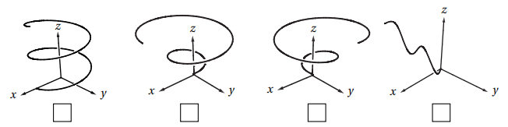
- Mark the picture of the curve in parameterized by for .

- Let C be the curve parameterized by for .
- Compute .
We see that

- Compute .

The direction of the curve has no influence on the value of a line integral with respect to arc length. We know that

- Find the mass of a thin wire in the shape of the curve where , if the wire has density function .

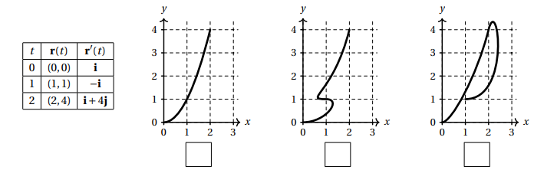
- Suppose that is a parametric curve in the plane and that and have the values given in the table at left. Check the box below the picture that could be a plot of .

- Let C be the oriented curve parameterized by where .
- Check the box next to the picture which best matches C.
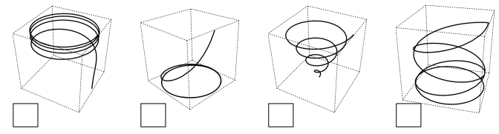

- Calculate the line integral

- Calculate the line integral .
We know that changing the orientation of the curve in a line integral with respect to x, y, or z will multiply the original result by -1.
Therefore,

- Suppose a wire can be modeled by the segment of the circle from to , when moving counterclockwise. If the linear density of this wire is measured by for any point on the wire, then set up an integral which represents the mass of this wire.

We know that the mass of the wire is given by where C can be parameterized at where . Therefore, we calculate that
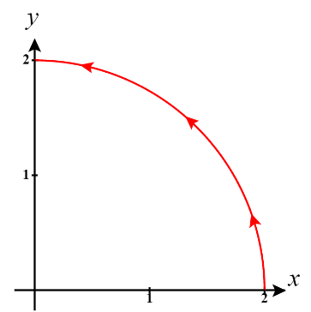

- Let , and C be a curve which is the intersection of the surfaces and from to . Compute the line integral .
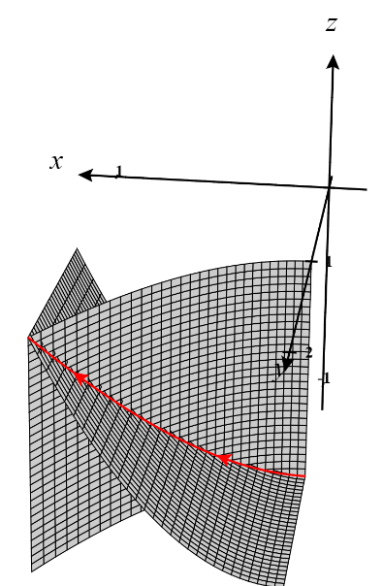
We can see that the intersection curve C can be easily parameterized as where .

Therefore, we compute that

- Evaluate the line integral , where C is the arc of the curve from to .
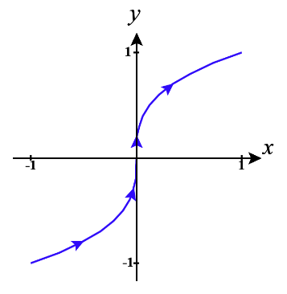
We first parameterize C as for .
Therefore,
Let . The bounds become . So we get

- Consider the line integral , where C is the arc of the curve parameterized by from .
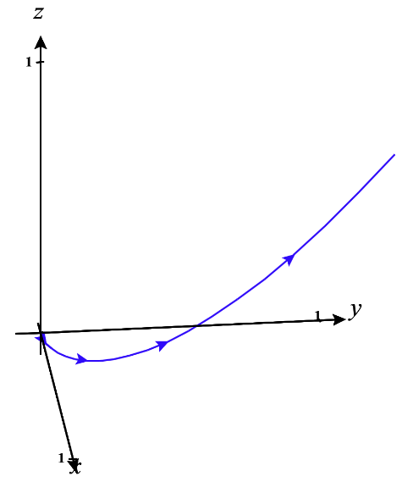
- Evaluate .
Let . The bounds become . So we get

- Evaluate .
We know that changing the orientation of the curve in a line integral with respect to x, y, or z will multiply the original result by -1.
Therefore,

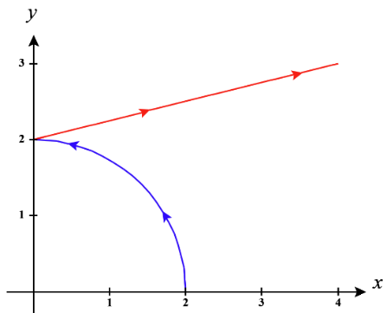
- Evaluate the line integral , where C consists of the arc of the circle from to followed by the line segment from to .

We will call the portion of C given by the circle with parameterization where .
We will call the portion of C given by the line segment with parameterization where . We know that
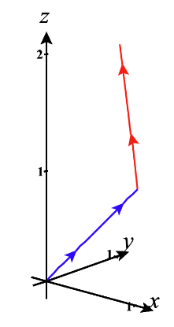
- Evaluate the line integral , where C consists of the line segments from to and from to .

We will call the portion of C given by the first line segment with parameterization where .
We will call the portion of C given by the line segment with parameterization where .
We know that

We calculate the line integral along each curve separately below.

Therefore,

